Algebra 1: Unit 7, Lesson 5

- The area model shown can be used to find the product $(8x-1)(4x+3).$
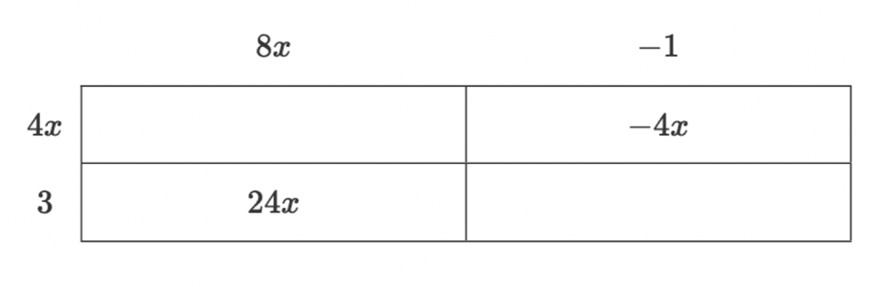
$$-3$$
Complete the area model.
$$32x^{2}$$

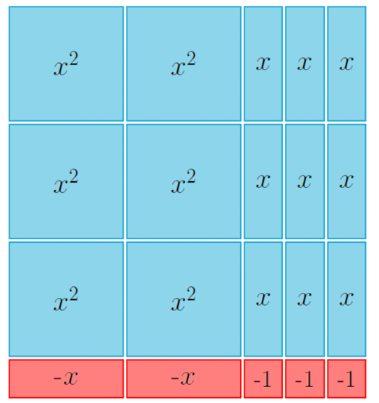
- A set of algebra tiles is shown.
The trinomial represented by the set of algebra tiles is $6x^{2}+7x-3$. A factored form of the trinomial represented by the set of algebra tiles is ________________.
$$(2x+3)(3x-1)$$

- A set of algebra tiles is shown.
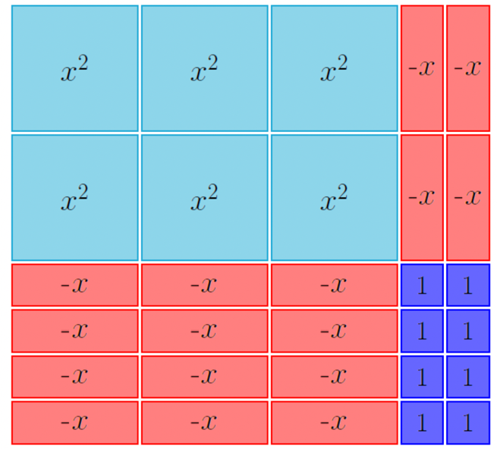
The trinomial represented by the set of algebra tiles is _____________________.
$$6x^{2}-16x+8$$

